6. Write a Pandas program to create a scatter plot of the trading

volume/stock prices ofAlphabet Inc. stock between two specific dates.

alphabet_stock_data:

Code:

import pandas as pd

import matplotlib.pyplot as plt

#Alphabet stock data

data = {

'Date': ['2023-01-02', '2023-01-10', '2023-01-18',

'2023-02-05', '2023-02-15', '2023-03-01',

'2023-03-10', '2023-03-20', '2023-04-05',

'2023-04-15'],

'Close': [91.80, 94.50, 96.20, 98.75, 101.30,

103.60, 105.40, 107.80, 110.20, 112.50],

'Volume': [25000000, 28000000, 26000000, 30000000,

31000000, 27000000, 29000000, 32000000,

33000000, 35000000]

}

# Create DataFrame

df = pd.DataFrame(data)

# Convert Date column to datetime

df['Date'] = pd.to_datetime(df['Date'])

# Select data between two dates

start_date = '2023-01-01'

end_date = '2023-03-31'

filtered_df = df[(df['Date'] >= start_date) &

(df['Date'] <= end_date)]

# Create Scatter Plot

plt.figure(figsize=(8,5))

plt.scatter(filtered_df['Volume'],

filtered_df['Close'])

plt.title('Alphabet Inc. Stock: Trading Volume vs Stock Price')

plt.xlabel('Trading Volume')

plt.ylabel('Closing Stock Price')

plt.grid(True)

plt.show()

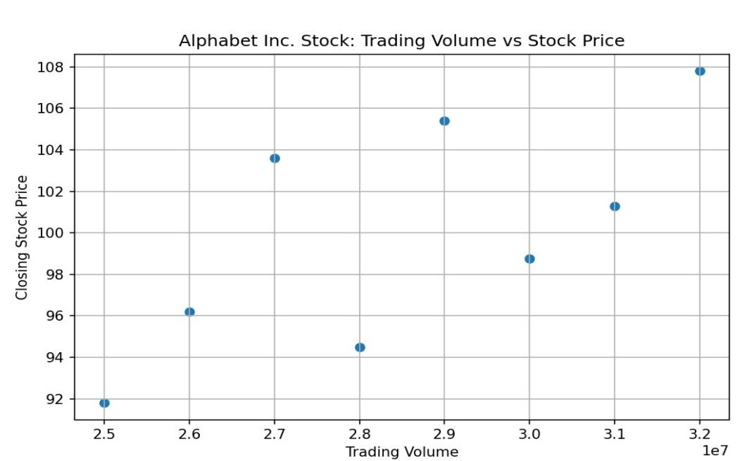
Output:

7. Write a Pandas program to create a Pivot table and find the maximum

and minimum sale value of the items.(refer sales_data table)

Code:

import pandas as pd

data = {

'Item': ['Television', 'Home Theater', 'Television', 'Cell Phone',

'Television', 'Home Theater', 'Television', 'Television',

'Television', 'Home Theater', 'Television', 'Home Theater',

'Home Theater', 'Television', 'Desk', 'Video Games',

'Home Theater', 'Cell Phone'],

'Sale_amt': [113810, 25000, 43128, 6075, 67088, 30000,

89850, 107820, 38336, 30000, 107820,

14500, 40500, 41930, 250, 936,

14000, 14400]

}

df = pd.DataFrame(data)

# Pivot Table

pivot_table = pd.pivot_table(

df,

values='Sale_amt',

index='Item',

aggfunc=['max', 'min']

)

print(pivot_table)

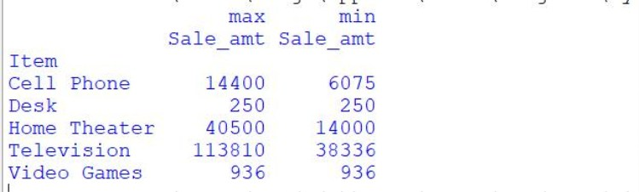
Output:

